Research document

Jumbo Project

Semester 7

The Green Team

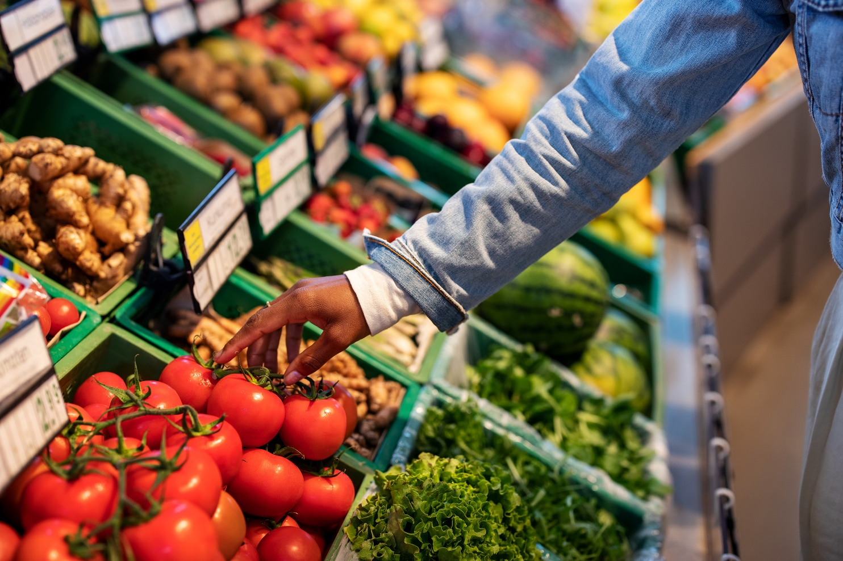

Contents

Main Research Question 2

Sub Questions 2

**1.** What is conscious consumption? 2

**2.** What defines Jumbo Supermarkets? 2

**3.** How does Jumbo compare to its competitors? 3

**4.** What apps or service does Jumbo currently provide? 4

**5.** What type of grocery shoppers are there? 6

**6.** What pain points do grocery shoppers experience in-store? 7

**7.** Which aspects of grocery shopping could add value to Jumbo and its customers? 8

**8.** How might we personalize the in-store grocery shopping experience? 8

**9.** How might we encourage shoppers to make more conscious decisions? 8

**10.** What technology could be used to create a mobile solution? 8

**11.** What are existing EU laws and regulations regarding food safety? 8

Bibliography 11

Main Research Question  
The question was derived from the given assignment, discussions with the client and other stakeholders. The main research is the center of all research made in this project.

It gave rise to the sub questions below and encouraged the team to apply various ICT research methods.

# Sub Questions

## What is conscious consumption?

**Goal: Clarification of the main research question**

**Methods: Literature Study (Library)**

**Results:** “Conscious consumerism is when buying practices are driven by a commitment to making purchasing decisions that have positive social, economic, and environmental impact.” Consumers question if the consumption is necessary, then once they decide to buy, they look carefully at who is providing the product and how the product impacts each environment touched in its creation and delivery.

**Conclusion:**

Conscious consumerism is gaining momentum as a movement. Eliminating impulse buys and opting for companies and products that create positive impact, consumers communicate a preference for better-for-the-world businesses and products.

**Recommendation:**

The businesses should tap into this new consumer movement if they wish to stay relevant.

## What defines Jumbo Supermarkets?

**Goal: Understanding the core values of Jumbo brand**

**Methods: Literature Study (Library)**

**Results: Customer is at the center of focus for Jumbo. They aim to offer the best quality products for the lowest prices all while making shopping experience enjoyable with the help of “7 zekerheden”.**

**Conclusion:**

Jumbo cares about the customer perception of the brand, they try to ensure the best shopping experience and predict the ever changing consumer interests.

## How does Jumbo compare to its competitors?

**Goal**

Finding out who the competitors from Jumbo are, and how Jumbo compares to them.

**Methods**

* Literature study (Library)
* Competitive analysis (Library)

**Results**

By searching on the internet for relevant sources and looking at Jumbo competitors and their offerings, the schema below was created.

|  |  |  |  |  |  |  |
| --- | --- | --- | --- | --- | --- | --- |
|  |  |  |  |  |  |  |
| No. stores | 685 | 445 | 420 | 985 | 270 | 507 |
| Market Share in % (2021) | 21.8 | 1.2 | 10.7 | 35.9 | 6.5 | 5.2 |
| Revenue | 9.9 billion EUR (2021) | 828.6 million EUR (2020) | $69 million (2021 NL) | 44.6 billion EUR (2021) | 2.61 billion EUR (2019) | 2.5 billion EUR (2018) |
| Selling Channels | Online, Local, Commercial | Online, Local | Local,  Online (non-food items) | Online, Local, Commercial | Online, Local, Commercial | Local |
| Awards | Online supermarket, Cheapest | ? | Fruit and vegetables | Packaging waste fund award | Meat products | Private label Product of the Year |
| Social Media Presence | Instagram,  Facebook, LinkedIn | Facebook (int.), LinkedIn (int.),  Instagram (int.) | Instagram,  Facebook,  LinkedIn | Instagram,  Facebook, LinkedIn | Facebook, LinkedIn | Instagram, Facebook, LinkedIn, Youtube |
| Delivery | YES | YES | NO | YES | YES | NO |

Table 1. schema with important details like market share and awards.

**Conclusion**

The most significant competitor of Jumbo is Albert Heijn. Besides having a bigger market share, more revenue, and having more stores, Albert Heijn is also perceived as “most sustainable” supermarket. Though, Jumbo won awards for having the best online shopping experience and being the cheapest.

**Recommendations**

As sustainability and customer perception is getting more important by the day, it could be a smart move for Jumbo to invest in being more sustainable and healthier.

## What apps or service does Jumbo currently provide?

**Goal**

Finding out what apps and services Jumbo provides, to find out if they are missing something.

**Methods**

* Literature study (Library)
* Available product analysis (Library)

**Results**

The following results were generated from looking on the internet and analysing existing Jumbo apps.

**1. Jumbo App (general)**

The main Jumbo app serves as an E-Commerce application. Some of the features are:

* Product catalogue
* Shopping list
* Online ordering with delivery
* Favourite products and recipes
* Find a store or Pick Up Point

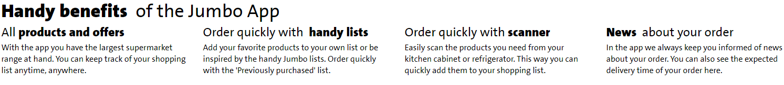

The general Jumbo app is mostly designed for deliveries. Through the app, it is possible to see the shopping list the user made and add it to either a home delivery or a pickup point order.

Other than this, the Jumbo app can also be used to make a shopping list which can simply be used in-store. Ordered per category, the products will be easier to find than searching manually.

The Jumbo app has a couple of premade lists of groceries, like ‘often forgotten’ or ‘bbq’.

Interestingly, despite not being advertised online, the app has a lot of useful features. A section in the app is called recipes and contains many categories from which recipes can be found. For instance, the first section is dedicated to a weekly changing menu. Categories like vegan, few ingredients or ready fast exist in order to filter exactly what the customer wants to see. It lists the amount of ingredients needed, how long the cooking will   
take and instructions for cooking.

Aside from this, the app also lists the bargains in a separate section. From the section, bargains can be viewed per week, season, deliveries only or all. From the general app, complaints can be filed as well. As a final note, from within this app, product codes can be scanned to enable quick paying at the register.

All functions described here are also available on the Jumbo website, with in-store scanning being the obvious omission.

**2. Jumbo Extra's app**

“Download the Extras app and create a digital pass or activate your physical pass. Enjoy all the benefits by always scanning your Extras pass at the checkout.”

With the Jumbo Extra's app, the customer can save points by shopping groceries. These points can be spent on a variety of items and activities. For instance, points that a customer saved can be spent on free groceries, amusement parks, sports and merchandise.

The customer can gather points by scanning their Extra's pass in store. As well as pass-scanning, the customer can choose specific items that have a temporarily increased amount of Extra's points.

The points saved can be used in physical form on paper or digitally by logging in to the app.

Finally, the app can be used for a couple of preferences. For instance, if the customer only wants to receive the receipts digitally, this can be applied in the setting with this app. This app also contains all the receipts that the customer has received while using the Extra’s pass.

**3. Jumbo Foodcoach app**

An app like the regular Jumbo app, focused on healthy recipes and recommending alternative products and ingredients to use.

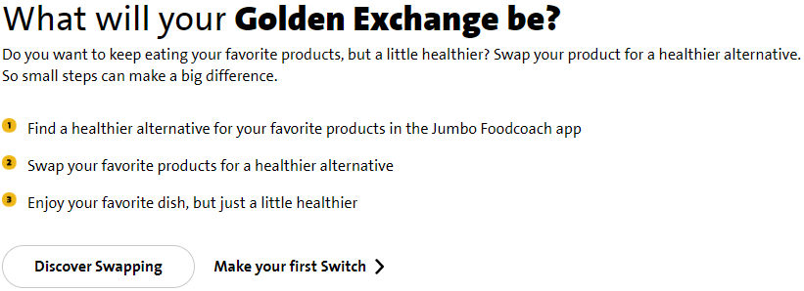

Features:

* Discover healthy recipes: low carb, low calories, vegetarian and sports-based diets.
* Add recipes to favourites in the order you want.
* Add recipes or single ingredients to your grocery list.
* Use your grocery list to order your groceries for pick-up or delivery.
* Get recommendations of recipes based on which sport you do.
* Save up points to use with your purchases.

Pitfalls:

* No English language support.
* Replica of the Jumbo app but with limited functionality. The few extra functionalities offered could be implemented in the actual Jumbo app instead.
* Some reviews say it's too focused on sports-based diets.

**Conclusion**

Jumbo currently provides three separate apps: Jumbo E-Commerce, Extra’s, and Foodcoach. The E-Commerce app is mainly used for ordering groceries online. The extra’s app handles discounts, points, and preferences about receipts. Lastly, the Foodcoach app helps users eating healthier, while still eating what they like.

**Recommendations**

Though the three apps serve different purposes, it could be a good idea to merge those into one general Jumbo app.

## What type of grocery shoppers are there?

**Goal: Identification of customer groups that make up the customer pool at Jumbo**

**Methods:**

**Results:**

|  |  |  |  |
| --- | --- | --- | --- |
| **Large seldom shoppers** | **Frequent buyers** | **List makers** | **Cart users** |
| **Scanner users** | **Self-checkout users** | **Conscious shoppers** | **Health fanatics** |
| **Inspiration seekers** | **Group shoppers** | **Loners** | **Lurkers** |
| **Queuers** | **Online shoppers** | **Chatters** | **Bargain hunters** |

**Conclusion:**

## What pain points do grocery shoppers experience in-store?

**Goal: Determine the difficulties shoppers experience during their shopping trip, based on the different types of shoppers described previously.**

**Methods: Literature study**

**Results**

**For many shoppers, grocery shopping is a chore. It takes a long time, there are long queues and products are difficult to find. For a lot of customers, this is all too familiar. But in order to get a wide range of pain points, the problems will be categorized for a couple of different customer types. This will be based on a literature study and the previously created persona’s and interviews.**

**For the infrequent shoppers that do large grocery shopping, the experience in-store will be vastly different to the frequent shoppers. Since they don't visit the store often and often prepare the shopping trip thoroughly, they are okay with taking some time in the store and are not as bothered by slowdowns. This demographic often uses a cart. They are not as likely to use handscanners and self-checkout. The gripes for this target group are largely product related. Unclear labeling and unhelpful employees are among the bigger annoyances. Empty shelves are also not appreciated.**

**In the case of frequent or impulse shoppers, the preparation is not as thorough. A lot of these customers simply go to the store when they're at home, realizing something is missing. Therefore, they often don't make a list and just go get the desired product. Aside from this, the slow progress at the cash-register is a bigger problem for this demographic. That means this group is likely to be more interested in self-checkout. Unhelpful employees are just as bad for this type of shopper as for the bigger shoppers, as are empty shelves.**

**For bargain-hunter shoppers, the most important thing is price. They don't care as much about self-checkout or quick moving queues and are focused on getting the best deal. Therefore, the bargain-hunter's gripes are to do with visibility. They want to be able to see the most discounted item instantly. Misleading and unclear packaging are a big problem for this type of customer. The bargain-hunter is also very disappointed to find products that are sold out.**

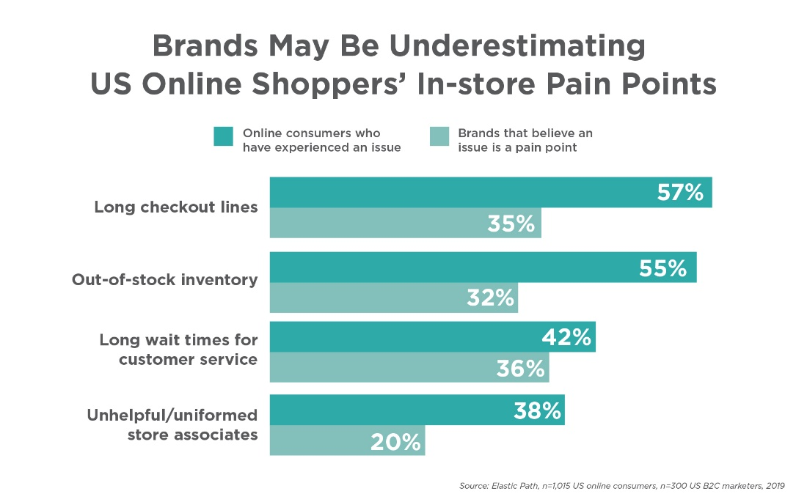

[~~https://smartwerksusa.com/articles/different-types-of-shoppers/~~](https://smartwerksusa.com/articles/different-types-of-shoppers/)

[~~https://www.vocovo.com/blog/post/revealed-retail-consumers-7-biggest-customer-experience-pain-points-in-2021/~~](https://www.vocovo.com/blog/post/revealed-retail-consumers-7-biggest-customer-experience-pain-points-in-2021/)

[~~https://retailwire.com/discussion/five-pain-points-grocers-must-address-to-survive-in-an-amazonwhole-foods-world/~~](https://retailwire.com/discussion/five-pain-points-grocers-must-address-to-survive-in-an-amazonwhole-foods-world/)

[~~https://www.therobinreport.com/four-pain-points-can-kill-physical-retail/~~](https://www.therobinreport.com/four-pain-points-can-kill-physical-retail/)

[~~https://supersavingtips.com/grocery-store-problems/~~](https://supersavingtips.com/grocery-store-problems/)

**Conclusion**

**For all customer groups, there seems to be some universal problems. Checkouts can be quite slow. Employees are not always helpful. Some products are not always available. There are, however, some differences among the different types of customers. The impulse shopper is way more bothered by slow checkouts than the other shopper types. On the other hand, although the impulse shopper is also frustrated by this, unclear labeling and illogical product placing is a bigger problem for the large shopper and the bargain hunter.**

**These problems can be quite far apart in terms of solutions. For this reason, in order to make a difference for Jumbo, it is important to establish what solution would be able to solve a lot of these problems.**

## Which aspects of grocery shopping could add value to Jumbo and its customers?

**Goal:**

**Methods:**

**Results:**

**Conclusion:**

## How might we personalize the in-store grocery shopping experience?

**Goal:**

**Methods:**

**Results:**

**Conclusion:**

## How might we encourage shoppers to make more conscious decisions?

**Goal:**

**Methods:**

**Results:**

**Conclusion:**

## What mobile app framework or technology best fits the Jumbo project?

**Goal:**

**Deciding on a mobile app development framework or technology that can be used to implement the concept. The choice will be made between Flutter and Android Studio as these aligned with personal development goals of the team members.**

**Methods:**

* **Literature study (Library)**
* **Community research (Library)**
* **Multi-criteria decision making (Workshop)**
* **Prototyping (Workshop)**

**Results:**

**First, information about both Flutter and Android was gathered. From these results, a multi-criteria decision-making table was composed.**

|  |  |  |
| --- | --- | --- |
| **Criteria** | **Flutter** | **Android** |
| **Cross platform (iOS, Android)** | **X** |  |
| **Descriptive and useful documentation** | **X** | **X** |
| **Active community** | **X** | **X** |
| **Access to native features** | **X** | **X** |
| **Highly customizable UI** | **X** |  |
| **Easy to compose UI** |  | **X** |
| **Hot-reload** | **X** |  |

**Then, a prototype for both possibilities was made. The goal was to implement a barcode scanner. This gave us an indication of the level of complexity involved.**

**Flutter: Very easy implementation, only a single external package needed**

**Android Studio: Easy implementation as well, also only required a single 3rd party package**

**Conclusion:**

**Based on the defined criteria, Flutter can do pretty much everything that Android Studio can. Moreover, it supports hot-reload which makes development more pleasant and it is a cross-platform solution, which was a deal breaker. So, Flutter fits the Jumbo project the best.**

## What are existing EU laws and regulations regarding food safety and allergens?

**Goal:** Understanding the expectations set by EU (in line with WHO) for food safety

**Methods:**

* Literature study (Library)

**Results:**

Cross-contamination and food allergies are an ever increasing concern in the EU and worldwide. The European Green Deal also plays an important part in pushing for waste reduction in food industry. Thus, there are strict regulations for food labeling. If food or beverages are sold in the EU, seller must provide essential information that is accurate, understandable and indelible including certain allergens. The consumer should be able to make an informed decision on their purchase based of it. In addition, the Food Safety Culture have been introduced, it enhances food safety by increasing the awareness and improving the behavior of employees in food establishments. Moreover, all food vendors must check the quality of the produce to ascertain it is not injurious to health and fit for human consumption.

**Conclusion:**

All businesses handling food must ensure that it meets the following criteria before serving/selling to the consumer:

* BBD leaves enough time for shelving and redistribution until final consumption
* Packaging integrity is undamaged
* Proper storage and handling conditions (i.e., temperature)
* Organoleptic properties
* Assurance of traceability for products of animal origin
* Labels matching the preset criteria.

There are also strict regulations for food labeling. Ingredient list must include any additives and allergen information, they must be listed in descending order of weight. Any allergens (substances or products causing allergies or intolerances used during manufacture or preparation and present in the finished product) present must be highlighted in the list of ingredients, by using a different font, letter size or background color. If there is no ingredients list, any allergens must be included by using ‘contains' followed by the name of the allergen. There are 14 main allergens that are required to be highlighted on labels:

1. Cereals containing gluten, namely: wheat, rye, barley, oats, spelt, kamut or their hybridised strains, and products

2. Crustaceans and products thereof (prawns, crabs and lobsters).

3. Eggs and products thereof.

4. Fish and products thereof (except fish gelatin or Isinglass used as fining agent in beer and wine).

5. Peanuts and products thereof.

6. Soybeans and products thereof (except fully refined soybean oil and fat).

7. Milk and products including lactose (except whey used for making alcoholic distillates and lactitol)

8. Nuts, namely almonds, hazelnuts, walnuts, cashews, pecan nuts, Brazil nuts, pistachio nuts, macadamia and products thereof (except for nuts used for making alcoholic distillates).

9. Celery and products thereof.

10. Mustard and products thereof.

11. Sesame seeds and products thereof.

12. Sulphur dioxide and sulphites at concentrations of more than 10mg/kg or 10 mg/liter.

13. Lupin and products thereof.

14. Mollusks and products thereof.

# Bibliography

Aanbiedingen folders. (2021, February 27). *Top 20 Grootste Supermarktketens Van Nederland*. Retrieved from Aanbiedingenfolders: https://www.aanbiedingenfolders.nl/blog/grootste-supermarktketens-nederland-7

Albert Heijn. (2022, Juni 9). *Albert Heijn en Hordijk winnen Afvalfonds Verpakkingen Award*. Retrieved from Nieuws AH: https://nieuws.ah.nl/albert-heijn-en-hordijk-winnen-afvalfonds-verpakkingen-award/

European Commision. (2021, March 3). *Food safety, allergies & food waste – new EU rules*. Retrieved from European Commison: https://ec.europa.eu/info/law/better-regulation/have-your-say/initiatives/12230-Food-safety-allergies-food-waste-new-EU-rules_en

European Union Law. (2011, October 25). *Regulation (EU) No 1169/2011 of the European Parliament on the provision of food information to consumers.* Retrieved from EUR-Lex: https://eur-lex.europa.eu/legal-content/EN/ALL/?uri=CELEX:32011R1169&qid=1668077990109

ExpatINFO Holland. (2022). *Biggest Supermarkets In Holland*. Retrieved from Expat i Holland: https://expatinfoholland.nl/help-guides/shopping-foods/10-largest-supermarket-chains-in-netherlands/

InterviewBit Compare. (2022, July 5). *Flutter Vs Android Studio: What’s the Difference?* Retrieved from InterviewBit: https://www.interviewbit.com/blog/flutter-vs-android-studio/#:~:text=Flutter%20provides%20access%20to%20the,it%20has%20already%20been%20created

Jumbo official page. (2022). *Het Bedrijf Jumbo*. Retrieved from Jumbo: https://www.jumbo.com/service/het-bedrijf-jumbo

Jumbo Supermarkten. (2022). *Het Bedrijf Jumbo*. Retrieved from Jumbo: https://www.jumbo.com/service/het-bedrijf-jumbo

Lewis, R. (2019, June 26). *Four Pain Points Can Kill Physical Retail*. Retrieved from The Robin Report: https://www.therobinreport.com/four-pain-points-can-kill-physical-retail/

Lonyai, K. (2017, September 5). *Five pain points grocers must address to survive in an Amazon/Whole Foods world*. Retrieved from RetailWire: https://retailwire.com/discussion/five-pain-points-grocers-must-address-to-survive-in-an-amazonwhole-foods-world/

Marktaandelen 2008-2020 Nielsen. (2020). *Marktaandelen*. Retrieved from Distrifood: https://www.distrifood.nl/food-data/marktaandelen

Nguyen, J. (2020, November 5). *Conscious Consumerism: What It is, How It Can Affect Change & 10 Ways You Can Be a Conscious Consumer Yourself*. Retrieved from GrowEnsemble: https://growensemble.com/conscious-consumerism/

Nielsen. (2021). *Market share of the leading companies in food retail in the Netherlands in 2021*. Retrieved from Statista: https://www.statista.com/statistics/589618/leading-companies-in-food-retail-netherlands/

Premo, M. (2019, November 14). *Here Are 5 Types of Customers You’ll Find in Your Store*. Retrieved from Smartwerks: https://smartwerksusa.com/articles/different-types-of-shoppers/

Robinson, O. (2021, February 8). *Revealed: Retail Consumers’ 7 Biggest Customer Experience Pain Points in 2021*. Retrieved from Vocovo: https://www.vocovo.com/blog/post/revealed-retail-consumers-7-biggest-customer-experience-pain-points-in-2021/

Salome, R. (2021). *AH grootste groeier van 2021*. Retrieved from Levens Middelen Krant: https://www.levensmiddelenkrant.nl/levensmiddelenkrant/nieuws/ah-grootste-groeier-van-2021

StackShare Community. (2020, July 27). *Android Studio vs Flutter*. Retrieved from Stackshare: https://stackshare.io/stackups/android-studio-vs-flutter

Weiner, G. (2021, August 24). *Grocery Store Problems: What You Want Is Becoming Harder to Find and More Expensive*. Retrieved from Super Saving Tips: https://supersavingtips.com/grocery-store-problems/

White, C. (2022, August 18). *What's a Competitive Analysis & How Do You Conduct One?* Retrieved from Hubspot: https://blog.hubspot.com/marketing/competitive-analysis-kit

Your Europe. (2022, September 16). *Food labelling rules*. Retrieved from Your Europe: https://europa.eu/youreurope/business/product-requirements/food-labelling/general-rules/index_en.htm#:~:text=Any%20allergens%20present%20must%20be,the%20name%20of%20the%20allergen.